

Local Website Training
WELCOME to your union site!

A Quick Reference Guide to navigate your local’s website.

Union Hall Log-in
- The Log-in link is located at the bottom of your webpage.
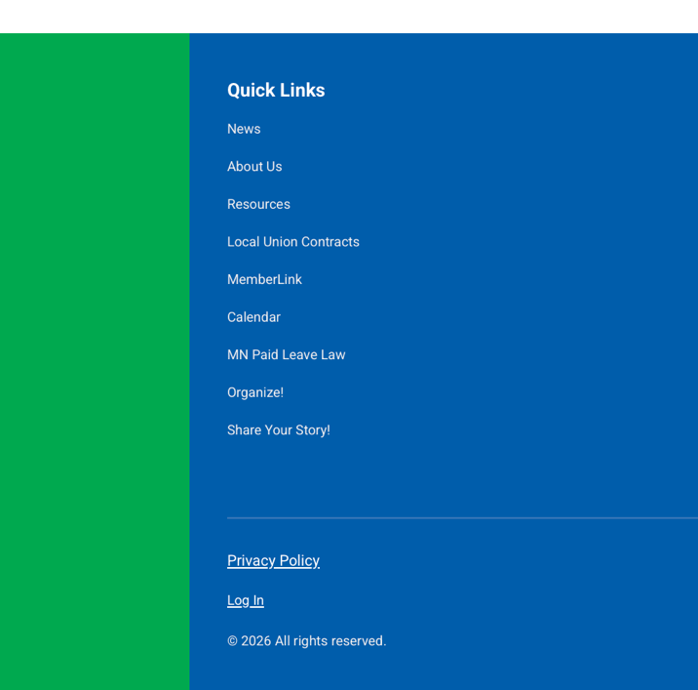
Authorize Members to Access the Local webpage
- Verify the Admin Bar settings on the top right side of the page.
- Click the Manage setting on the top side of the page, then click on the Add single member. Add the new Local administrator information using a personal email address.
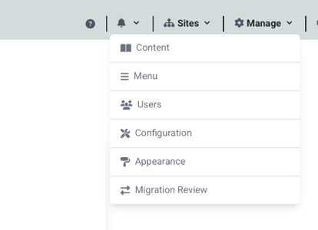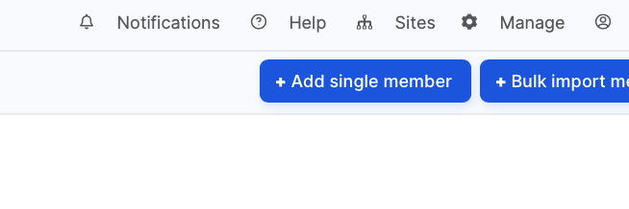
- Click on Add single member.
  - Create user name (First_Last Name)
  - Add a home email address. This will generate an email from Union Hall with login credentials to the website. The new user will then create their password to the site.

Navigating the Site

HOMEPAGE

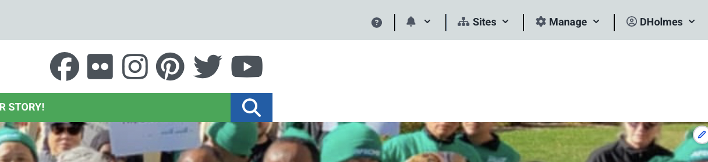

- Admin settings are located on the top right corner of the website.
- Page Editing tools appear on the lower right corner of the website page. The editing tools will change depending on the type of page being edited.
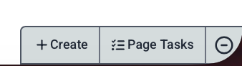
- Menu Bar
  - To add a Menu item linked to another page (ex: MemberLink, member card),
    - click on Manage > Menu > Add Link
    - Name Link
    - Add the URL link
  - To change a Menu link name
    - Click on Manage > Menu > Edit > Save
  - To change the order of a Menu item
    - Click on Manage > Menu
    - Drag the + sign of the menu item
  - To remove a Menu item
    - Click on Manage > Menu
    - Click on Edit (located on the same line on the right side)
    - Click Remove
Social media

Menu bar
Hero pic

- Hero Pic (i.e. main page photo)
- Social media – check with Communications to edit this information
- Question mark is linked to Union Hall website with in-depth information and videos. You can also find the same training videos on YouTube by searching for “Union Hall training.”

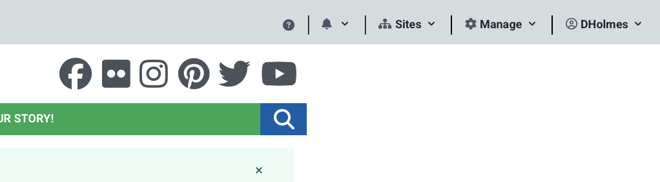

About Us Biography pages
- Create a new Bio page
  - Create > Add Biography
  - Enter information
  - Save
- Edit Officer Bio Page Local Officers Name, contact phone/email, bio
  - Go to About Us page
  - Click on the bio picture
  - Edit
  - Edit the Bio page
  - Save
- To remove a Bio page
  - Click on the bio picture
  - Edit
  - Unpublish
  - Save
- To Change order of Officers
  - Click on the Open Reorder Form
  - Drag Names using the “+” icon
  - Save your changes.
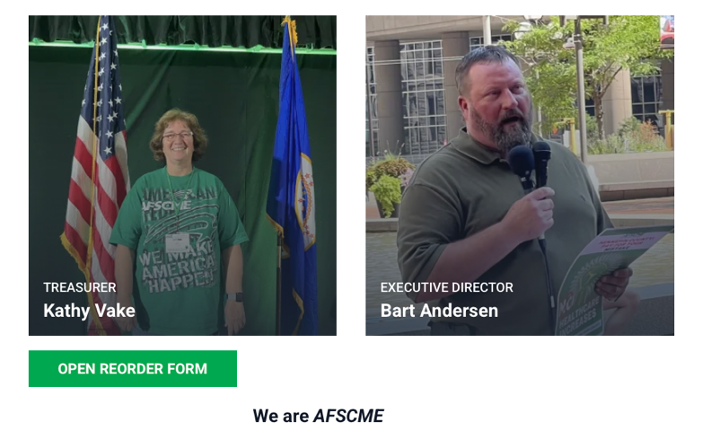

News Article

This feature adds a news item to the front page as well as the News page.
  - Create > Add Article
  - Update the Body section with News including a picture (optional)
  - SAVE
  - Check the page for how the info appears on the News page.
  - Edit to make additional changes

To remove a news item:
- Select the news article
- Edit > Unpublish

To edit a news item:
- Select the news item
- Edit
- Make your edits
- Save

Calendar
To add a calendar item:
- Create > Add Event
- Complete all fields (event name, date, description, location)
- Recurring event – if the meeting occurs on a regular basis (daily, weekly, monthly)
  - Does Not Repeat > select appropriate recurrence or Custom
- Save

To edit a calendar item:
- Go to calendar
- Select the calendar item
- Edit
- Make your changes
- Save

To delete a calendar item:
- Go to calendar
- Select the event
- Edit
- Unpublish
- Save

Upload Files to Shared Library
To create a shareable file such as a flyer, agenda, minutes, etc., it is recommended that the file be saved as a pdf to create a direct URL link to the file. You can upload a Word document or Excel spreadsheet for a downloadable link.

Published but unlinked pages (i.e., hidden page accessible only with a URL)
  - Create > Basic Page
  - Midway down the page, click on Media Browser (second icon from left)
    - 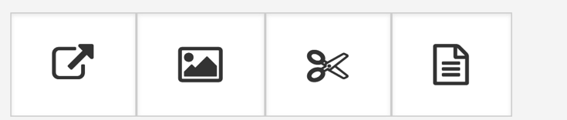
  - Click Browse
  - Upload media by dragging file to box,
  - Click on upload media
  - Click on Next
  - Click on Save to save the media,
  - Click Save again to save the media to the webpage
  - This will take you out of edit and to the webpage
  - Go to the bottom of the webpage and click on the pdf
  - Open the pdf
  - Copy the url link at the top of the browser window,
  - Go to the page to edit the page with the URL link to the pdf.
  - Remove the pdf from the webpage

Create a Webpage for Member-Only Documents (such as Monthly Minutes and Treasurer Reports).
A workaround is to upload member-only, non-public documents by creating a published but “unlinked” BASIC PAGE. The URL link to this webpage is shared with members to access meeting minutes and treasurer reports. This page also serves as a way to file documents on the webpage versus Google docs or the employer’s server.

Note: Save Word documents as pdfs for quick access. Word docs require downloading before viewing.

Create a Memberlink Tab (or any tab)
- Click on the settings option located on the left side of the page.
- Click on Menu.
- Click on Add Link.
- Fill in Menu Link Title, Path, and Description fields as listed below .
- Save.

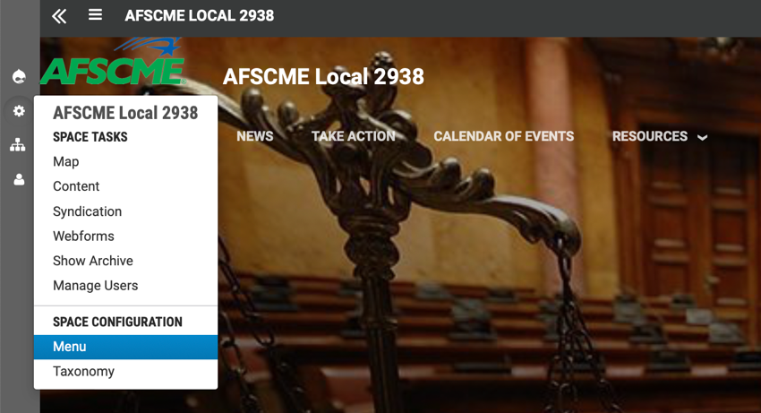

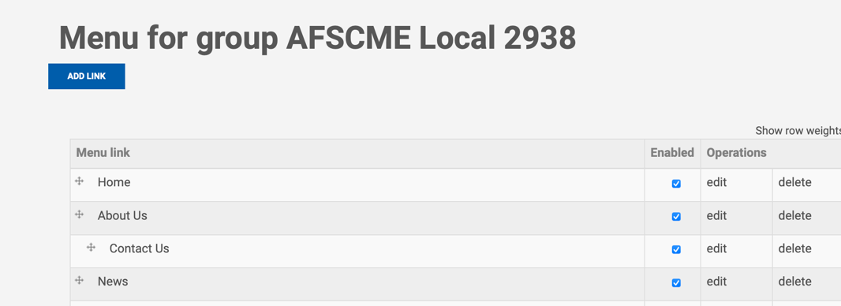
FYI: You can edit a tab’s name by clicking here.

- Action Items
  - Create Action (Page Editing, Create Action)
    - Fill in the form (title, body, Action Network URL to petition)
    - Recommend clicking the box to link to Menu Bar.
    - Must add an image to your action within in the form. Recommend adding tags for viewing-impaired, as well as for internet searches.
  - Allows user to quickly jump to an Action Network page. (Note: This action is coordinated between your field rep and C5 communications.)
  - To edit the action page, hover over the uploaded image and click on the edit icon.

- News Content

