

Action Network Email Training

Our training will walk through how to use Action Network for emails and member lists. This is a powerful tool that helps us stay connected, keep members informed, and mobilize quickly when action is needed. Our goal is to make sure you feel confident using Action Network to reach members, track engagement, and strengthen our union’s communication.
Requesting an Action Network Account
Communications submits a request to AFSCME International Union (IU) for a Local’s page in Action Network (the web application we use to send email blasts with AFSCME C5 branding.
IU sends a URL link to the Local’s member administrators along with log-in credentials.
Tip: Bookmark or pin this website to your web browser.

Upload Member Lists
Before sending out an email, make sure your lists are ready to upload in the correct format.

- Save your Excel spreadsheet as a .csv file.
  - Label each column appropriately
    - Use lower case caps
    - Use underscore between words (ex: last_name and first_name).
    - Email column header should be email.

  - Name the file clearly.
    - Indicate if it has home or work emails.
    - Note the member type. Example: Member, New Hire, New Member, Freeloader, or ALL (includes non-members and freeloaders).
    - Include the date in MM.DD.YY format.

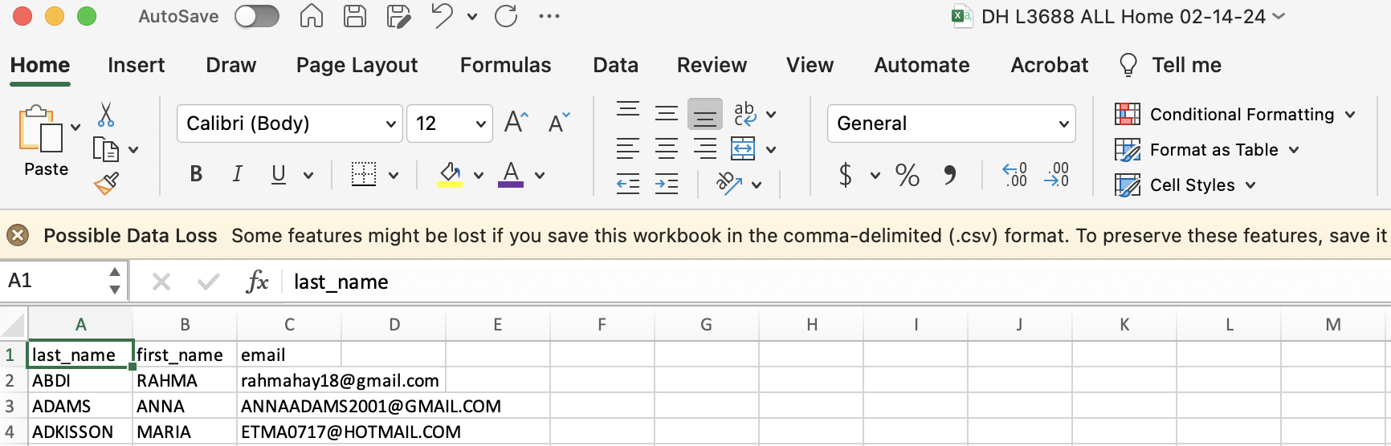

- Upload the file in Action Network.
  - Go to People > Uploads > Add New Upload > Browse for a File
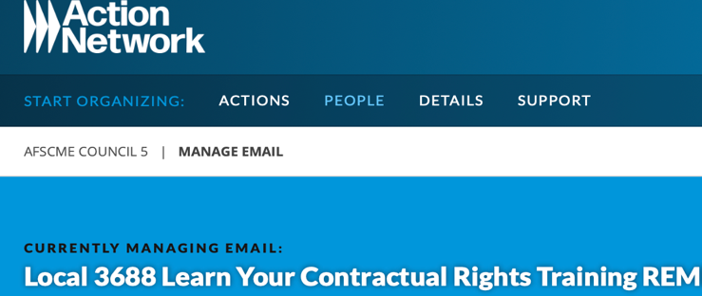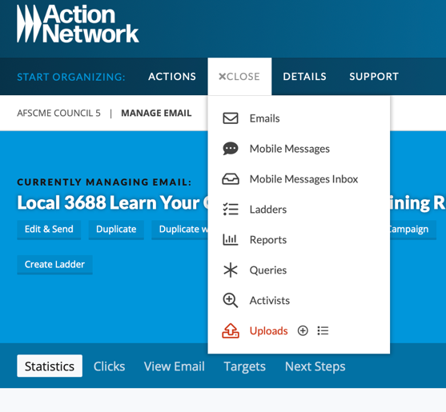

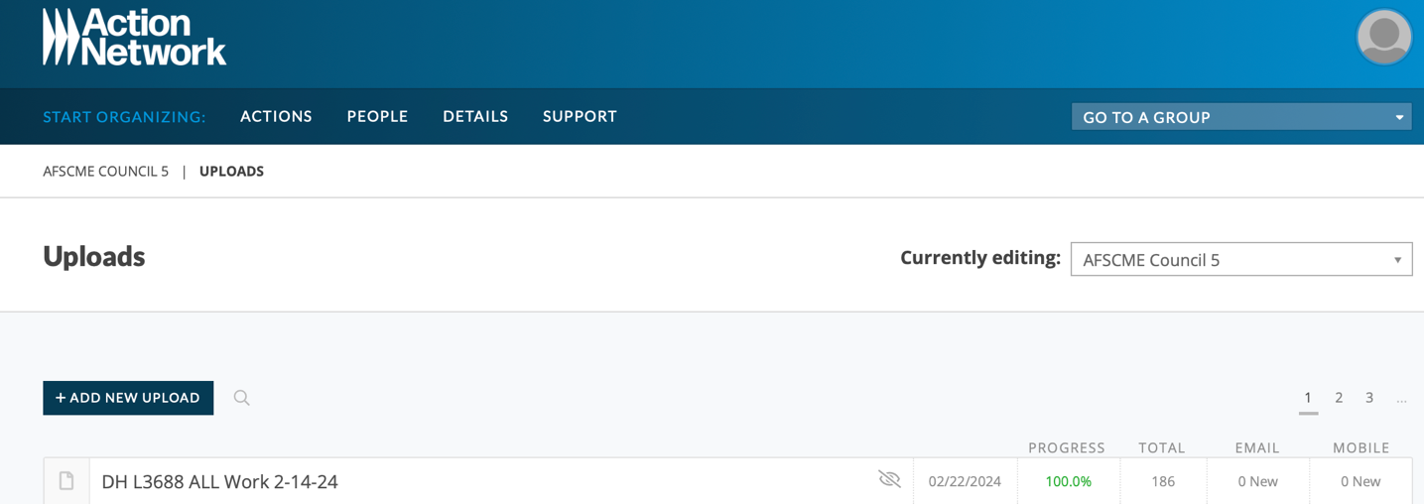
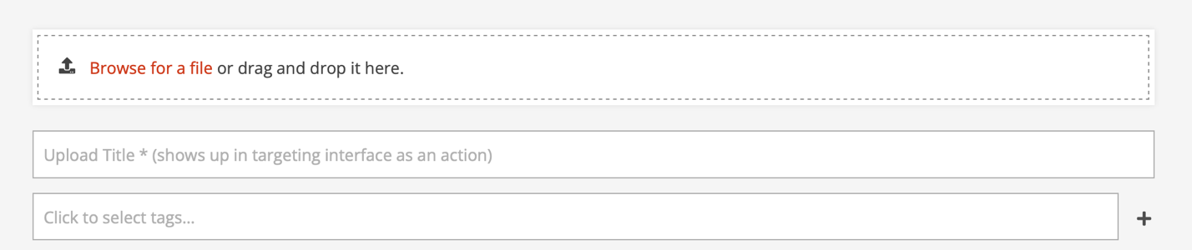

- Enter Upload Title (ex: L3688 Member Home, L3688 Non-Member-Freeloader, L3688 New Hires 2-14 thru 3-14-24). Copy this info to use for the tag.
- Click on the + sign to add the tag.
- Upload and Match Fields
- Select Last Name for the last_name field
- Upload
- This process will take 5-20 minutes to upload, sometimes longer.
- Refresh the screen to monitor the progress. When the 100% is in green, then the list is ready to use.

Drafting and Scheduling the Email
- Go to People > Email to open a new email.
- Draft the email.
- Send an email test to review.
- Save and Target the email.
  - Select Target section to expand the menu.
  - Go to Tag -
    - Start typing file name (ex: L3668 Member Home 2-14-24)
    - Add Council 5 staff list (include Bryce.Wickstrom@afscmemn.org, Diana.Holmes@afscmemn.org, Max.Hall@afscmemn.org
- Save and Send.
- Schedule Email by selecting the Schedule feature
  - Select date on the calendar
  - Select time (uses Eastern time). Good rule is to send at least 15 minutes later to give you time to think about any last-minute changes.
  - Schedule and Save
  - If you need to change the time, unscheduled the email by going to edit mode and repeat Steps 6a-c.

Duplicating Draft or Sent Emails
This feature is handy for recurring meeting or reminders. Click on the multi-page icon to duplicate the email and start editing. Repeat Steps 3-6 above.
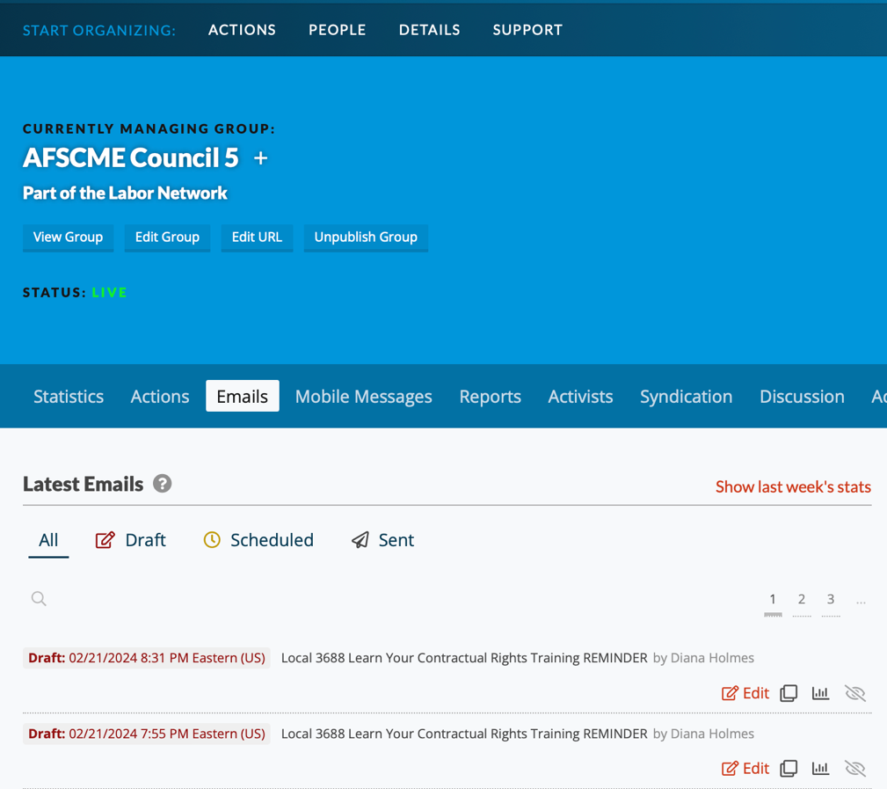

Notes:
- If member did not receive home and/or work email, verify info on the original spreadsheet.
  - If this info does not match, contact the MAC at (651) 450-4990 to check and update our member database.
  - If this info does match and the member wishes to receive future communications, contact Diana Holmes to check the Action Network database. This member may have unsubscribed from email blasts sometime in the past.
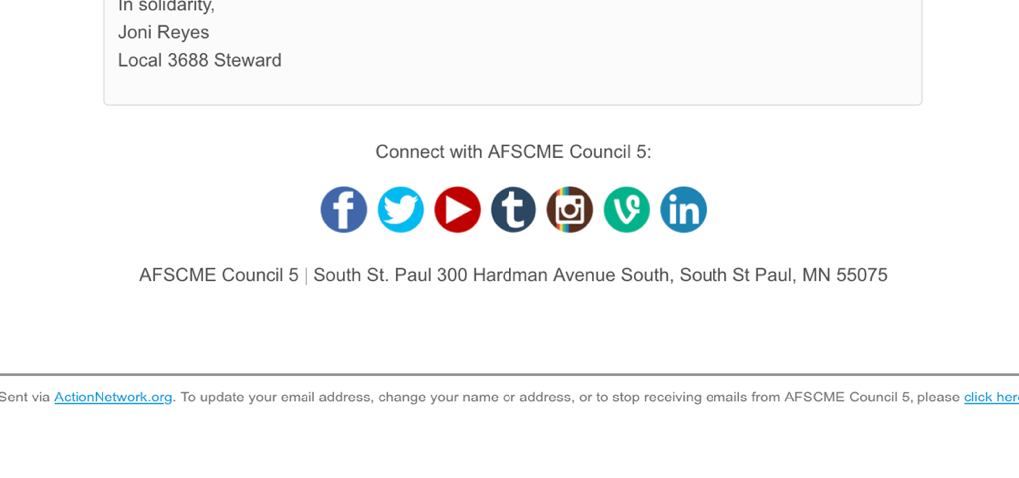
Thanks for taking the time to learn Action Network! The best way to get comfortable is by practicing: send a test email, explore the Activist functions, and don’t be afraid to click around. Remember, this tool is here to make our work easier and our union stronger. If you run into questions, please reach out.

We’re all learning together, and the more we use Action Network, the more effective we’ll be at engaging members and building power.

