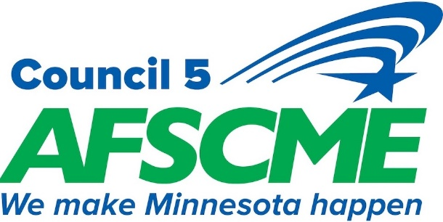
STATE EMPLOYEE POLICY COMMITTEE
SPRING CONFERENCE AGENDA
Friday April 17th, 2026
St. Cloud Rivers Edge Convention Center

Time Event Room

8:00am

8:00 – 10:00 AM Registration

10:00 AM Welcome
President’s Address
Executive Director Address
External Affairs and Planning Director
Election
Chair Officers
Legislative Update
11:15 Break

11:30am Department Policy Committee Nominations Meeting
DHS
HEPC
DNR
GENERAL
DOC
VETERANS AFFAIRS
MNSTATE
12:00-1:00 PM Lunch

1:00-1:45 PM Department Policy Committee Elections –
DHS
HEPC
DNR
GENERAL
DOC
VETERANS AFFAIRS
MNSTATE

2:00pm Bargaining Structure Approval

2:15pm Resolutions

2:30pm State Contract Information

3:00pm Closing/Oath of Office

