**Cell Phone Directions to the Local 3139 Website**

You can go directly to our website by going to [**https://www.afscmemn.org/local-3139**](https://www.afscmemn.org/local-3139) or using the QR Code

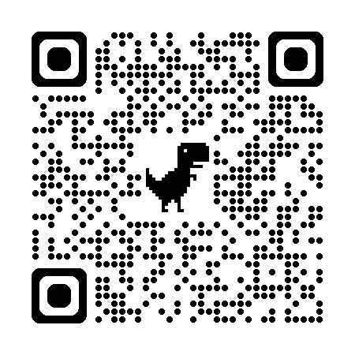

For detailed steps from the AFSCME website, follow the steps below.

**Step 1:** Go to [www.afscmemn.org](http://www.afscmemn.org) on your browser of choice; e.g. Chrome, Edge, Safari

**Step 2:** Click on the 3 bars in the upper right corner.

**Step 3:** Click on the 3rd arrow across from resources. Then click on Council 5 Local Unions. DO NOT CLICK on Resources.

If you see the page below, you will need to restart step 2 and click on the 3 bars icon in the upper right.

**Step 4:** Scroll down until you find our local 3139 Department of Administration. It is towards the bottom of the page.

**Computer Directions to the Local 3139 Website**

You can go directly to our website by going to [**https://www.afscmemn.org/local-3139**](https://www.afscmemn.org/local-3139)

For detailed steps to get there from the AFSCME website using a **COMPUTER**, follow the steps below

**Step 1:** Go to [www.afscmemn.org](http://www.afscmemn.org) on your browser of choice; e.g. Chrome, Edge, Safari

**Step 2:** Hover over the Resources tab in the upper left corner, and click on Council 5 Local Unions. DO NOT CLICK on Resources or you will be brought to a new page. You cannot find the local website from that page.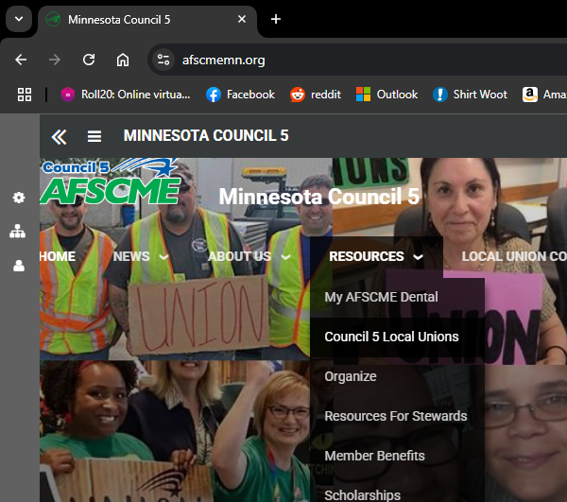

If you see this page, hover over the Resources tab and click on Council 5 Local Unions.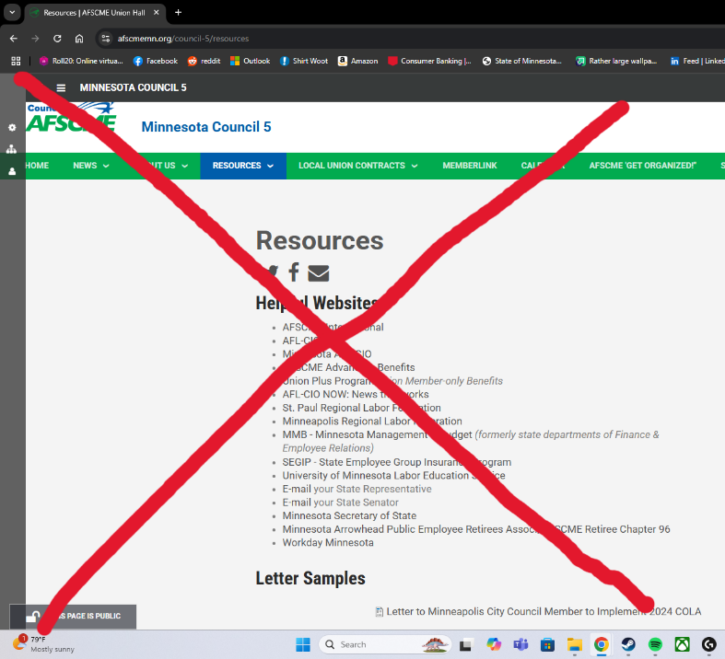

**Step 3:** Scroll down until you find our local. Click on Local 3139 – Department of Administration. That will bring you to our website.